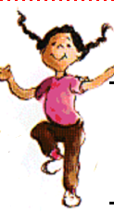
- Screen child with the RPSB Screening tool.
- Using the Iowa-Nebraska norms, if the student has one or more developmentally significant errors that are stimuable, he is eligible for RTI.

- If the child has been referred for language concerns. Screen the child with the RPSB screening tool.
- Check his grades and DRA score.
- Consult with the teacher to see where his weaknesses are.
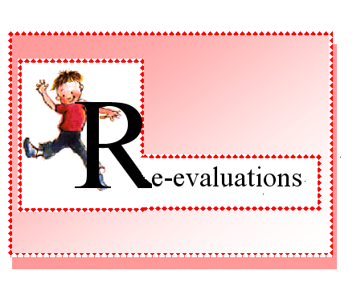

- If a child has been referred for fluency, give the screening test noting any dysfluencies and secondary characteristics.
- If the child is dyfluent at least 5% of the time, refer for RTI.

